Explanation of "interrupting" moves in alpha firmware 1.7.6 (D301)

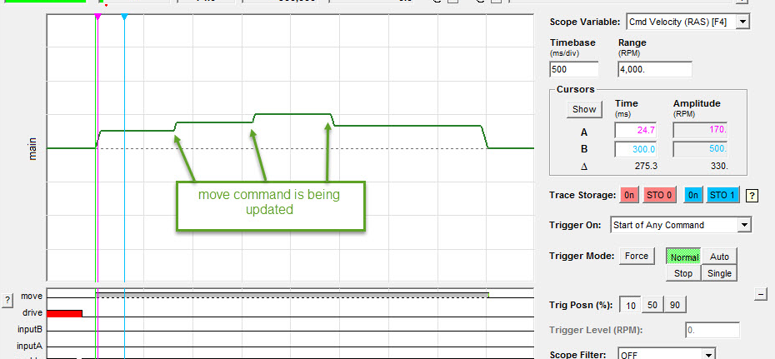

An interrupting move is a move which will interrupt a previously commanded or buffered move. The new move will start at the current commanded velocity, ramp up/down to the new commanded velocity and/or decelerate to reach a new position target.

In the above picture, you can see a normal positioning move being interrupted three times with a new velocity limit and position target. In the image below, you can see what the original move would have been had it not been interrupted.

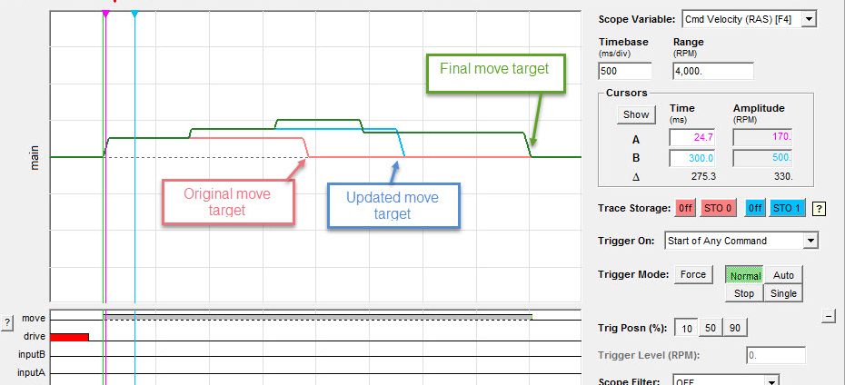

Interrupting moves are specified by the internal motor parameter #98 when this parameter is set to 1 (theNode.Info.Ex.Parameter(98, 1);) all types of commanded moves will be considered interrupting. When the parameter is set to 0, moves will buffer and complete as normal.

